|  |  |
| --- | --- |
| **Proposal For Research Grant**  STATE OF THE ART COMPUTING SYSTEM DEPLOYMENT TO  IMPROVE AGRICULTURAL SECTOR OF PAKISTAN | |
|  | |
|  | |
| **Project Identification** | |
| **Project Title:**  **STATE OF THE ART COMPUTING SYSTEM DEPLOYMENT TO IMPROVE AGRICULTURAL SECTOR OF PAKISTAN** |
| **Quaid-e-Awam University of Engineering, Science & Technology**  **Principal Investigator-1 (PI):**  **Name: Dr. Syed Raheel Hassan**  **Designation:** Assistant Professor  Mobile # : 0336-2292402 Tel. # : +92 (0) 244 9370 381-85 Ext 2636  Email: [raheelhassan@questedupk](mailto:raheel.hassan@quest.edu.pk)  **Coprincipal Investigator-1 (PI):**  **Name: Prof. Dr. Saleem Raza Samo**  **Designation: Pro Vice Chancellor**  Mobile # : Tel. # : +92 (0) 244 9370 381-85 Ext 2108  Email: [sfaizsamo@yahoocom](mailto:sfaizsamo@yahoo.com)  **Coprincipal Investigator-2 (PI):**  **Name: Dr. Umair Ali Khan**  **Designation:** Assistant Professor  Mobile # : Tel. # : +92 (0) 244 9370 381-85 Ext 2640  Email: [umairkhan@questedupk](mailto:umair.khan@quest.edu.pk)  **NED University of Engineering & Technology**  **Principal Investigator-2 (PI):**  **Name: Dr. Muhammad Khurram**  **Designation:** Assistant Professor  Mobile # : 0335-3046110 Tel. # : 021-99261261-68 Ext 2287  Email: [mkhurrum@neduetedupk](mailto:mkhurrum@neduet.edu.pk) |
|  | |

# Contents

SUMMARY 5

1. OBJECTIVE 6

2. MOTIVATION & NEED 6

2.1: Policies proposed by the Government of Pakistan: 6

2.2: USAID Initiatives for development in Agriculture Sector of Pakistan 7

3. TARGETED ISSUES & PROBLEMS 7

4. OVERVIEW 8

5. GOALS 8

6. SCOPE OF STUDY 9

7. TECHNICAL DETAILS 9

7.1.1: Wireless Sensor Network (WSN) 10

7.1.2: Wireless Sensor Unit (WSU) 10

7.1.3: Wireless Coordinator Node (WCN) 10

7.1.4: Wireless Server Module (WSM) 11

8. CURRENT STATUS 12

8.1: Implementation dates 12

9. BENEFECERIES 12

10. ASSOCIATION OF QUEST WITH NEDUET 12

10.1: Counterpart personnel and support staff 12

10.2: Available office space, vehicles, equipment and etc. 13

11. PROJECT TEAMS 13

11.1: Job Description of Team Members 14

12. BUDGET 15

12.1: Recurrent Cost 15

12.2: Possible Total cost for both Sites 16

12.3: Project Deployment Site Addresses 16

12.4: Function of the Equipment 17

13. INCENTIVE OF SMART AGRICULTURE IN THE NATIONAL DEVELOPMENT PLAN 17

13.1: Environmental and Social Considerations 17

13.1.1 Poverty Eradication 17

13.1.2 Agriculture Fights the Effects of Global Warming 18

13.1.3 Water Conservation and Water Health 18

13.1.4 Social benefits to human resource 20

13.1.5 Hands on exposure/Learning 21

REFERENCES 22

APPENDIX 23

**SUMMARY**

The Internet of Things (IoT) has the potential to change the world. "Internet of Things" points out a vision of machines communicating with each other by forming a network, sharing information relevant to their tasks and acting on them with little to no external human interaction. In the nineteenth century, machines learned to do, in the twentieth century, they learned to think, in the twenty-first century they are learning to perceive so they can actually sense and respond to their environment.

The applications of Internet of Things are innumerable. Embedded devices can be in-charge of collecting and distributing information across a network with limited processing capabilities and low power requirements. Among countless applications of the IoT one is known as Smart Irrigation. Through this Smart application the combination of emerging technologies including ubiquitous computing with sensor network can be applied on agriculture domain to make the agriculture smarter.

The purpose of this project is to make this system reliable, efficient, accurate, and user friendly for the farmers of Pakistan. The System aims to design and implement an irrigation system for fields in Pakistan that is efficient in water usage. It also aims to educate clients about their specific irrigation needs and allows them to take advantage of the latest technological innovations available. Ultimately, this system helps the farmer to cultivate healthy crops without stress. In this way, it adds some flexibility to the farmer’s schedule strengthens the plants and helps to maintain good productivity.

# 1. OBJECTIVE

The objective of this project is to design a smart irrigation system using state of the art computing technologies, which would benefit the agricultural sector of Pakistan. The intent of this application is to get information from the Wireless Sensor Network (WSN) that employs various sensor networks to acquire various environmental parameters from the field to automate the irrigation process.

# 2. MOTIVATION & NEED

A huge portion of Pakistan’s economy is dependent on the agricultural sector; 50% of the total population relies on farming & cultivation for their income. Nowadays the agriculture sector is encountering numerous major problems and its growth rate decreasing every year which results declining in GDP. In 1947, 53% of the total GDP of Pakistan was based on agriculture but unfortunately today it contributes only 23% [1] [2]The reason for such a rapid downfall is that the crops and fields are not monitored properly. There is need to apply scientific technology as other countries are adopting worldwide. In Pakistan still old traditional ways of farming are in practice, farmers solely use his experience to look after his fieldsWater availability is the major factor to increase productivity in agriculture sector. Currently the archaic method of irrigation which is in practice all over the country wastes almost 50% - 60% of Pakistan’s water resources [3] [4]. Since fresh water resources are already scarce in Pakistan so there is need to propose technology based solutions of irrigation which utilized water in efficient manner.

## 2.1: Policies proposed by the Government of Pakistan:

(National/Provincial Development Plan & Sector Development Plan)

The key elements of government’s development plan are agriculture and availability of enough food supplies. According to the Framework for Economic Growth, "Vision 2030", the Medium Term Development Framework and the Poverty Reduction Strategy Paper II (PRSP-II) pay major attention on the role of agriculture. However, these plans may or may not be considered a substitute sufficient for comprehensive agricultural policy. Agriculture Policies for Growth & Poverty Alleviation by the Government of Pakistan through irrigation efficiency has following main components [5]:

* To make the Water usage efficient by lining the water courses.
* Judicious use of the surface and water tube, the lining of water should be pre planned keeping in mind the surface area. The jobs of the farmer holds no security, the intent is to form organizations which would provide respectable & permanent jobs with sophisticated salaries, increased public investment, urge the public to take more interest in the agricultural sector. Another motive is to experiment with sprinkle and drip irrigation.
* In Pakistan Government policy, Irrigation scheme generally proposes raising the irrigation water from the underground resources and low water ponds by pumping devices, bringing the water to the fields located at higher elevations through GI and PVC pipes and water supply to areas of lower or equal elevation through open channels. Connecting various areas in three RCC depressions or PVC pipes and making a central distribution points and providing turnouts at those distribution points.
* Government of Punjab province is taking interest in high efficiency irrigation systems like “drip irrigation” and “sprinkle irrigation”. They also wanted to convert these irrigation systems which are powered by solar energy to save electricity.

## 2.2: USAID Initiatives for development in Agriculture Sector of Pakistan

USAID is an independent agency of the US. Government that provides economic development and humanitarian assistance around the world in support of the foreign policy goals of the United States. According to USAID report related to “Pakistan food and agriculture systems” highlighted main reason for degradation of agriculture sector is not adopting new technology, low investment in research and development, in developing or disseminating higher production packages, in maintaining an effective agricultural education and extension system, and in maintaining physical infrastructure. USAID has started many projects related to agriculture some of them are following [6-8]:

* **USAID & ASF Launch Agribusiness Project**

The five-year Agribusiness Project is funded by the American people through USAID and is implemented by ASF. The project aims to address priority constraints impeding the development of Pakistan’s agriculture sector with a focus on horticulture and livestock sub-sectors. (2009-on going)

* **USAID Pakistan, Irrigation Support Project for Asia and Near East**

Participated in the evaluation of the Command Water Management Project. (August-September 1988).

* **USAID/Pakistan buy-in, Agricultural Policy Analysis IQC (subcontracted by Abt Associates)**

In collaboration with the Harvard Institute for International Development, completed policy studies on edible oils and livestock feed, and background studies on rural land and labor markets, and the sources of agricultural productivity. (1990-1992)

* **USAID/Pakistan Agricultural Research Council/Abt Associates, Agricultural Policy Analysis and Teaching Workshop** (December 1991-January 1992).
* **USAID Mission in collaboration with EDC in Pakistan**

EDC was one of seven firms selected by the mission to provide M&E services to USAID Pakistan in the areas of health, education, economic growth, and democratic governance. (2004-2006)

* **USAID, Irrigation Support Project for Asia and the Near-East**

For Pakistan country, study of the environmental sustainability of urban-rural water resource development and management (Faisalabad District as a case study). (April-May 1993)

# 3. TARGETED ISSUES & PROBLEMS

Agriculture sector uses 85% of available freshwater resources worldwide, most of which are gone wasted. If the amount of water continues to be utilized by the agriculture sensor, this may poses a serious threat to the water resources. The population is growing rapidly, food and water demands are also increasing [9] meanwhile fresh water resources are decreasing, and therefore it is required to make the efficient use of water on the first priority [10]. There is an urgent need to create strategies based on science and technology for sustainable use of water [11] [12]. Smart irrigation system using state of the art computing technologies for agri area of Pakistan has been designed to counter/target the following issues and problems faced by the Agriculture sectors:

* Lack of quality labor in the agriculture field leads to low production. State of the art computing systems for agri area of Pakistan offers an observable and controllable system with which it would be possible to keep track of the field as well as the labor.
  + - It is very important in farming to determine, at what time, what amount of water is required by the crops. The main focus of this project is to provide controlled and timely distribution of water in the fields.
    - Currently, there are no field monitoring systems available in Pakistan which could monitor a vast area/field. This project is scalable, efficient & can easily provide coverage to a large area.
    - Water resources are reducing each passing year. Crops suffer badly due to lack of fresh water. In advance stage of this project we can find in advance the amount of water required in different areas and seasons. It will help framers to take appropriate decisions about cultivating new crops.

# 4. OVERVIEW

Various sensors (humidity sensors, water flow sensors, temperature sensors etc) are deployed in the field; the data from these sensors is forwarded to a server module which uploads it to a remote site via a LAN connection using Raspberry Pi single board computer. The application on the remote site updates the log file which makes intelligent decisions like weather or not the crop need watering, whether or not the crop has been infected etc. In this way the farmer can easily monitor his fields without having to personally visit the fields or checking on each crop individually thus saving a lot of timeThe final output of this proposed system will be fully functional & intelligent. This automated irrigation monitoring system with smart sensing will be very economical in terms of the cost of equipment. This smart application is the combination of emerging technologies including ubiquitous computing with sensor networking and can be applied on agriculture domain to make the agriculture system intelligent.

# 5. GOALS

* The quality of labor at work in the agricultural fields is poor due to lack of technical education, incentives and facilities This project will help in monitoring the crops by the workers during every day, tasks in large areas which could not be accessed easily otherwise.
* It would enhance the quality of work on the field and could increase the yield of the crop.
* This project will also target remote monitoring of the crops against the attack of any pest or plant decease. It would allow the farmer to take timely actions to save the plants from such attacks.
* The project’s objective would contribute to increase agriculture production, employment and incomes, higher living standards and positive environmental outcome. Water reservoirs in Pakistan are being utilized at a very fast pace. The lack of dams and other reservoirs results in drought; this not only destroys the green fields and livestock but also threat to human lives. The construction of new dams/reservoir needs a lot of investment and time, therefore the only hope of salvation is save whatever water resources have been left. This triggers the necessity of saving water; this can be achieved by the use of digital & precise auto-irrigation or State of the art computing systems for agri area of Pakistan system. Water reservoirs in Pakistan are being utilized at a very fast pace. The lack of dams and other reservoirs results in drought; this not only destroys the green fields and livestock but also threat to human lives.
* Water reservoirs in Pakistan are being utilized at a very fast pace. The lack of dams and other reservoirs results in drought; this not only destroys the green fields and livestock but also threat to human lives. The construction of new dams/reservoir needs a lot of investment and time, therefore the only hope of salvation is save whatever water resources have been left. This triggers the necessity of saving water; this can be achieved by the use of digital & precise auto-irrigation or smart irrigation using State of the art computing technologies for agri area of Pakistan.
* Another objective of this project is to design a system which would detect the crop’s quality that whether crop is healthy or not. It has also been planned to implement a monitoring system which would be using Artificial Intelligence as its main tool, this feature maybe used to predict the seasonal affects etc. it is intended to the make the system intelligent enough to take decision on its own and perform timely actions.

# 6. SCOPE OF STUDY

Deployment of this project in fields would not only vastly increase the production but would also decrease the material investments and resource requirement. Development of smart agriculture system requires promising technologies and innovations that would result in farm productivity. The areas which would be targeted by smart Agriculture for study includes:

* WSN (Wireless Sensor Network)
* Control System
* Power Harvesting Source

# 7. TECHNICAL DETAILS

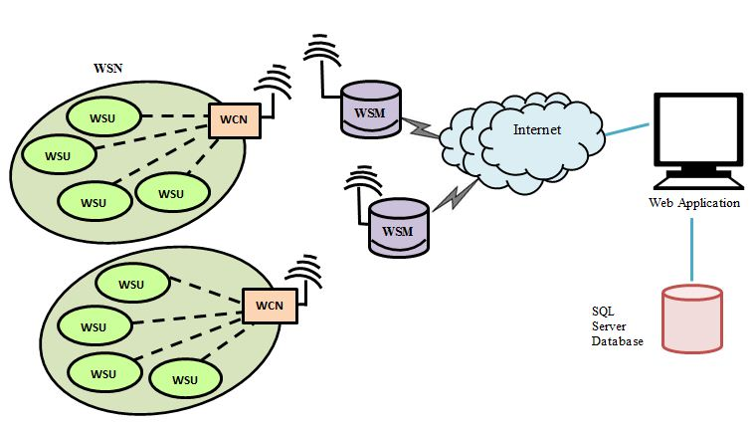The project is divided into two parts one is related to hardware development and the other one is related to software development. Each section is described in detail below:

Fig. 1 Architecture of State of the Art Computing System Deployment to Improve Agricultural Sector of Pakistan

**7.1: Hardware Organization**

The State of the Art Computing Systems for Agri Area of Pakistan consists of four main modules. These modules include Wireless Sensor Units (WSUs), Wireless Coordinator Node (WCN), Wireless Server Module (WSM) and Remote Site.

### 7.1.1: Wireless Sensor Network (WSN)

The Wireless Sensor Network is linked by ZigBee transceivers. The transceivers make the nodes wireless in order to transfer sensor’s data and other status parameters to a remote site/main server wirelessly. The main server node has a LAN connection through which it sends the entire gathered information from the field to the Web Application using internet. The transceivers make the nodes wireless in WSN introduces new capabilities for measurement and control applications. The power of wireless sensor networks lies in the ability to deploy large numbers of tiny nodes that assemble and configure themselves. It consists of different wireless nodes and these nodes are spread in a particular environment to monitor certain parameters (i.e. collect and route data). The concept of WSN can be defined by the Equation (1):

Sense + Process + radio frequency (RF) = WSN Application ---------------------Eq. (1)

The WSN developed in the system used ZigBee technology. It is defined by IEEE 802154 standard for personal area network. In WSN, various sensors are interfaced with each node. They require battery to sustain at a remote location. The key features of WSN are low power and low cost but less memory and processing capability. ZigBee technology supports these features as compare to other wireless technologies like Bluetooth (802151 standard) and Wi-Fi (80111b standard). The transmission range of ZigBee is 1000-1500m. It can support 65,000 nodes in a network while other technologies cannot support such a big number of nodes. In short, ZigBee is more scalable, flexible, reliable, and less complexes as compare to other wireless protocols. The only limitation while using ZigBee is its low data rates (250 kbps). In WSN the data transmissions do not require high bandwidth. Therefore, ZigBee is the best suited technology to be used for this application.

**7.1.2: Wireless Sensor Unit (WSU)**

Wireless Sensor Unit is one of the most salient components of the deployed system. Each unit incorporates power source, microcontroller, sensors and RF transceiver for this application. A variety of sensors have been used. This include water flow sensors, humidity sensors, Hygrometers (soil moisture sensors), external and internal temperature sensors. All these sensors will provide the data about the field. This information is used to take further agricultural intelligent decisions. All the sensors are interfaced with the high performance, low power AVR series microcontrollers ATmega8/ATmega328 The pins of the controller are interfaced with sensors and Xbee, through the serial port. A separate board for providing the sensors power has been created. A 13V Lithium battery is used to provide the voltage. It is regulated by a 78H05K regulator to maintain the voltage at 5V for Arduino which then further lowers the voltage to 33V for Xbee. Moisture sensors provide analog values to be read by Arduino. They range from 0 to 1023, from wet to dry. The microcontroller is programmed to receive data parameters from these sensors and organized the entire data in the form of a packet. The data is then transmitted serially through ZigBee transceiver. Xbee series 1 has used in sensor node. Encryption and checksum/CRC techniques are also introduced in the ZigBee transceiver to make data secure and error free.

**7.1.3: Wireless Coordinator Node (WCN)**

The WCN of a typical WSN works as a sink node. It is very similar to the sensor node and operates as a master microcontroller. It has several crucial tasks to perform. The additional features in it are filtering data, alarm generation system and communication with wireless server module. The architecture of WCN consists of power source, sensors, alarm system, Processing Unit (AVR microcontroller) and wireless communication module (XBee Pro series 1). The sensors provide data from the field which goes to ADC block for data sampling and quantization further it is processed in processing unit and stores in memory for short term history logging. If there is any disturbance in hardware it generates an alarm. All the gathered data will then be sent to the server module through wireless communication.

### 7.1.4: Wireless Server Module (WSM)

Fig. l l 1 Architectural Layout of Web Application

This module basically acts as a bridge between the WSN and the remote site. This module consists of power source, XBee transceiver, Raspberry Pi (R-Pi), SD card and LAN connection. The UART (universal asynchro- nous receiver transmitter) pins of Raspberry Pi (R-Pi) single board computer are considered as a powerful feature to connect it with the external world. These pins are used to interface XBee Series 1 transceiver with R-pi. Through this transceiver R-Pi is wirelessly receiving information from the WCN. The SD card provides storage to Operating System and files. It is used to maintain history logging of the fields’ param- eters. R-Pi is configured to enable LAN connection. Socket programming has been implemented using python on R pi to send the received packets to the software application. TCP communication protocol has been used as a GPRS transmission plane. It enables two hosts to establish a connection and exchange streams of data. It guarantees delivery of data and in order transmission. Here, it is required that information from the field should not be lost because certain processing parameters on the remote Site rely on the nature of collected data from the field.

**7.2: Software Implementation**

The Software Application for visualizing, monitoring, calculating, and storing the field parameters is programmed in C# programming language. The platform used to develop the application is Microsoft Visual Studio 2010. The data values are stored in tables and these tables are managed by creating stored procedures. SQL Server 2008 Management Studio has used in this productive application for table management. The Web Application is developed for visualizing and storing real time data from the field.

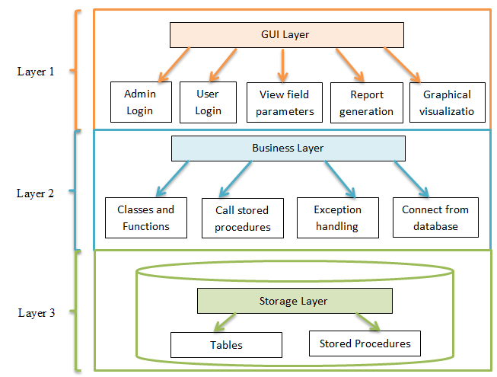

**Graphical visualization**

**visualization**

Fig. 2 Architectural Layout of Web Application

The software basically consists of three main layers (Fig. 2):

1. A graphical user interface layer to read and visualize the sensor’s information.
2. A business layer which is programmed to receive data from the internet and store it in the database.
3. A storage layer to store all the information in the form of tables and stored procedures to access the relational tables.

Through this secure application the farmer can easily keep track of his field by checking certain realistic parameters. It actually permits an authorized user to access the data of any particular field. All the gathered information from the cloud is stored in the database. The Web application displays all the statistical parameters from the field. **Soil moisture**, **Temperature**, **Humidity**, and **Water flow**. On the bases of the gathered data this application is calculating the water usage on hourly, weekly, daily and monthly bases.

# 8. CURRENT STATUS

After preliminary study, it was planned to implement initial prototype module within six month for small field area. The first module consists of wireless sensing network (WSN), data processing and control unit modules. The next step is to move towards the automation of irrigation system to distribute water in selected areas.

## 8.1: Implementation dates

Day Month Year ~ Day Month Year

01 may 2015 ~ 30 OCTUBER 2015

# 9. BENEFECERIES

Nowadays the efficient use of fresh water is a burning need in Pakistan, therefore efficient and intelligent irrigation management is a major concern in agriculture. Working on designing an intelligent irrigation system is to target labor and water saving [6] [7]. The following are the direct and in direct beneficiaries of this system:

* Farmers
* Common people
* Traders
* Industrialist
* Provincial Government and Government of Pakistan

The proposed system is an application of modern technology which is being implemented worldwide. State of the art computing systems for agri area of Pakistan is likely expected to provide a boost in agricultural sector of Pakistan fresh water is required by each individual of Pakistan therefore the water saved through this project would be indirectly utilized by the individuals. The Overall beneficiaries of this project will be the individuals living in the country.

# 10. ASSOCIATION OF QUEST WITH NEDUET

## 10.1: Counterpart personnel and support staff

Quaid-e-Awam University of Engineering, Science & Technology” research group will be working in this project with “NED University of Engineering & Technology “research group. Also, Computer & Information Systems Engineering (CIS) Department of NED University of Engineering & Technology, Karachi is working in collaboration with the Koshish Foundation (an NGO) to carry out this project.

The execution of this project is in its second phase, the first prototype of this project has been deployed. Currently, four (04) MEngg. Research Assistants and (06) undergraduate BE. Research Students were part of the previous research and development team.

## 10.2: Available office space, vehicles, equipment and etc.

CIS is providing lab space with limited support of computers, Internet and technical staff for development and maintenance purposes.

# 11. PROJECT TEAMS

Now two research groups will work together on this project, Quaid-e-Awam University of Engineering, Science & Technology and Ned University of Engineering & Technology as described in following table:

|  |  |
| --- | --- |
| Team:1 (Quaid-e-Awam University of Engineering, Science & Technology) | |
| ***Title / Position*** | ***Number*** |
| Principle Investigator (PI) | 01 |
| CoPrinciple Investigator(Co-PI) | 02 |
| Research Students (RSs)/ Research Assistants (RAs) | 04 |
| Support Staff | 01 Technician |
| 01 Gardener |
| Team:2 (NED University of Engineering & Technology) | |
| ***Title / Position*** | ***Number*** |
| Principle Investigator (PI) | 01 |
| Research Assistants (RAs) | 03 (Masters Students) |
| Research Students (RSs) | 03 (Under graduate Students) |
| Support Staff | 01 Technician |
| 01 Gardener |

|  |
| --- |
| Teams Structure: |
| **PI**  Dr. Raheel  **PI**  Dr. M. Khurram  **Co-PI**  Prof.Dr.Saleem Raza Samo  **Co-PI**  Dr. Umair Ali Khan  **RA**  XYZ  **RA**  XYZ  **RA**  XYZ    **RS/RA**  XYZ  **RS**  XYZ  **RS**  XYZ  **RS**  XYZ  **RS/RA**  XYZ  **RS/RA**  XYZ  **RS/RA**  XYZ |

## 11.1: Job Description of Team Members

**Principle Investigator:**

The PI will be responsible getting funds for the project and shall look after throughout the life of the project. They shall resolve any problems related to project development (technical or managerial) or other that will be encountered during the project.

**Coprincipal Investigator (Co-PI):**

The Coprincipal Investigator is responsible for proper documentation, recruit students, perform on site visits regularly and coordinate with the team members on daily basis. Co-PI will organize training and farmer awareness programs as well as use linkages with the field experts & contact local farmers.

**Research Assistant:**

The Research Assistant is responsible for new findings in different research aspects and works in development phase. RA also directs the Research Students and assigns tasks, also they proposes new ideas. Along with these responsibilities, RAs will be the backbone of design and development process (hardware / software).

**Research Student:**

The Research Students learn new skills and will be exposed to research, new technologies, system development, different software tools as well as they learn about existing and new technologies in hardware.

# 12. BUDGET

**Proposed Resolutions for 3000 m2 Area (100m x 30m):**

20 x 06 = 120 nodes (01 node per 5 meter length)

**Development Cost with proposed Resolution**

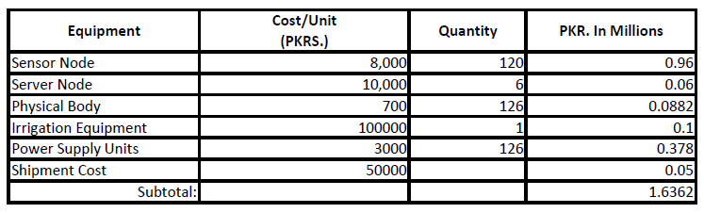

* For detailed cost estimation please refer to appendix (page# 24).

## 12.1: Recurrent Cost

This is for each research group

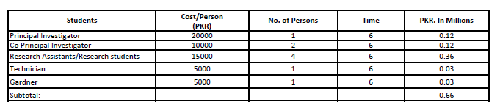**Stipend for Quaid-e-Awam University of Engineering, Science & Technology**

**Stipend for NED University of engineering & technology**

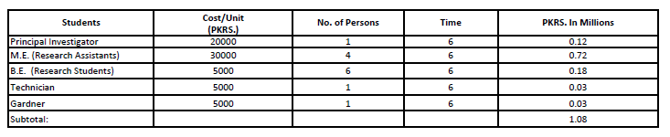

## 12.2: Possible Total cost for both Sites

|  |  |
| --- | --- |
| **Quaid-e-Awam University** | |
| Development cost | 1.6362 Million PKR |
| Stipend | 0.66 Million PKR |
| Miscellaneous | 0.1 Million PKR |
| University Utility Bills / Costs - @ 15% | 0.35943 Million PKR |
| **Total Cost (Quaid-e-Awam University Research Group) (A)** | 2.75563 Million PKR (approx) |
| **NED University of Engineering and Technology** | |
| Development cost | 1.6362 Million PKR |
| Stipend | 1.08 Million PKR |
| Miscellaneous | 0.1 Million PKR |
| University Utility Bills / Costs - @ 15% | 0.42243 Million PKR |
| **Total Cost (NED University Research Group) (**B**)** | **3.23863** Million PKR (approx) |

**Total Cost (A+B) =** 5.99426 **Million PKR**

## 12.3: Project Deployment Site Addresses

1. Quaid-e-Awam University of Engineering, Science & Technology.
2. Department of Computer & Information Systems Engineering, NED University of Engineering & Technology.

## 12.4: Function of the Equipment

The equipment will be used to support the researchers and developers in their study, training, design, and development and in installation phases. The equipment mentioned above is essential for this project. Further details can be provided on demand. The equipment will be operated by the research and technical staff of the Department of Computer & Information Systems Engineering.

# 13. INCENTIVE OF SMART AGRICULTURE IN THE NATIONAL DEVELOPMENT PLAN

Since Pakistan is an agricultural country and 21 % of the total revenue of Pakistan is from agriculture, therefore priority of this project in National Development Plan must be at top to give a splendid rise in Pakistan’s economy earned through agriculture. Agriculture automation has a wide range of benefits on the government sector level. Most of the crops are destroyed due to over watering of the fields and no proper soil posture. By introducing modern technologies in agriculture, better of farming will be implemented and more yield of crops is possible. Hence, this project has a great importance in the betterment and future of agriculture in Pakistan.

## 13.1: Environmental and Social Considerations

The use of renewable energy source to power up the system will reduce the effect of global warming which is increasing day by day due to burning of fuel.

* Irrigation has contributed significantly to poverty alleviation, food security, and improving the quality of life for rural populations.
* By the saving of water the life of the Pakistani Nation would flourish.
* Water is applied in such a way that salt is not allowed to build up in the soil. The farmers would gradually interact with the project descriptors and eventually get educated about the project and its working. This way the farmers and the other individuals will be technically educated.

The State of the Art Computing Systems for Agri Area of Pakistan shall influence the following factors:

### 13.1.1 Poverty Eradication

The relative contribution of a sector to poverty reduction is shown to depend on its direct and indirect growth effects as well as its participation effect. The poor participate much more in growth in the agricultural sector, especially in low-income countries, resulting in much larger poverty reduction impact. Together, these findings support the overall premise that enhancing agricultural productivity is the critical entry-point in designing effective poverty reduction strategies. Yet, to maximize the poverty reducing effects, the right agricultural technology and investments must be pursued, underscoring the need for much more country specific analysis of the structure and institutional organization of the rural economy in designing poverty reduction strategies. Fig3 shows the trend of poverty population (percentage) vs. year.

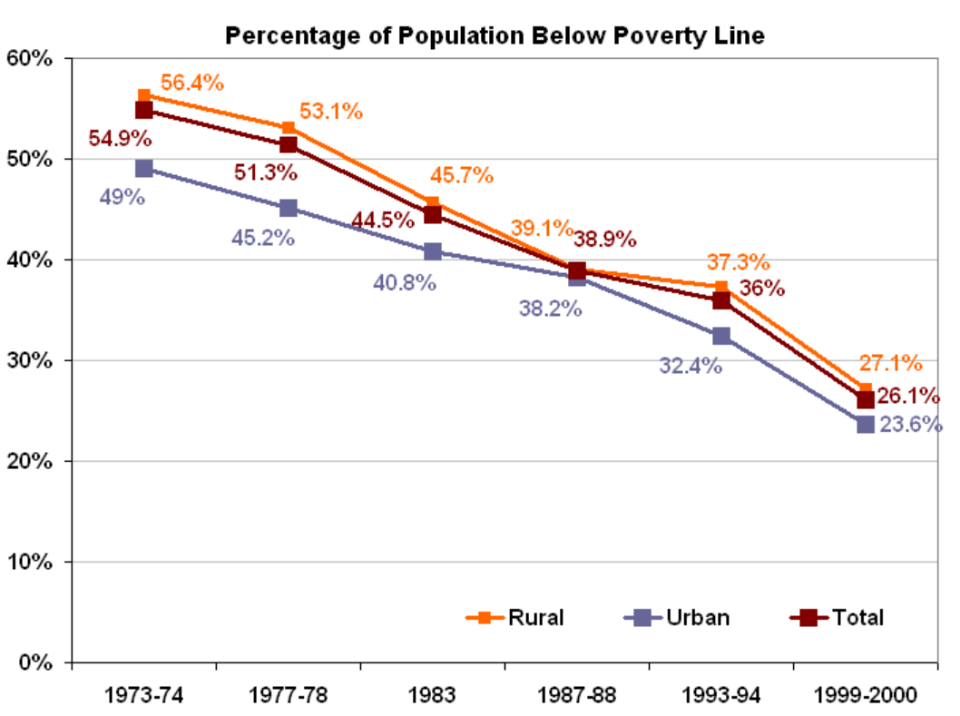

Fig3 Rural poverty in Pakistan

### 13.1.2 Agriculture Fights the Effects of Global Warming

Research shows that a healthy organic agriculture system can actually reduce carbon dioxide and help slow climate change. In fact, a research shows that:

"If only 10,000 medium sized farms in the US. Converted to organic production, they would store so much carbon in the soil that it would be equivalent to taking 1,174,400 cars off the road, or reducing car miles driven by 1462 billion miles"

### 13.1.3 Water Conservation and Water Health

Dwindling water supplies and poor water health are very real threats. When water supply is at risk, people and the planet end up suffering. Adverse environmental effects such as harmful pesticides, toxic fertilizers and animal waste results due to insensitive irrigation. This automatic irrigation system helps keep our water supplies clean by stopping that polluted runoff. It also helps to conserve water. Following graphs visualizes predicted trends and behavior of different effects over State of the Art Computing System Deployment to Improve Agricultural Sector of Pakistan by adoption of smart irrigation strategies.

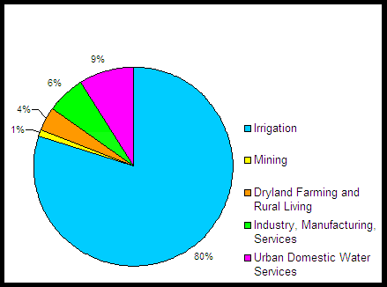

**Fig5 Water Usage without technological advancements**

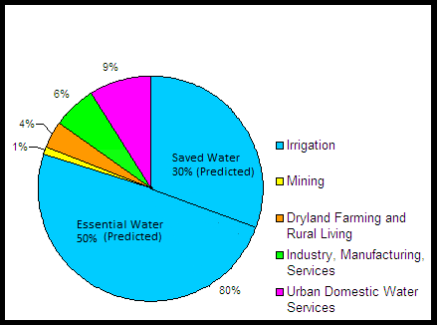

**Fig6 Water Usage with technological advancements**

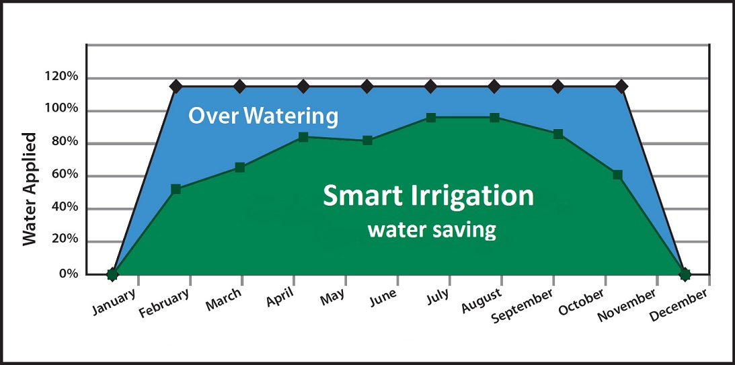

Figure7. predicted water saving by "Smart Irrigation” State of the Art Computing System Deployment to Improve Agricultural Sector of Pakistan

### 13.1.4 Social benefits to human resource

The technological transformation of traditional agriculture will be difficult without a matching effort to develop human resources; hence it becomes essential through educational reforms to produce researchers more attuned to the needs of rural peoples and agriculture becomes a need so that targeted human resources and the agriculture sector may mutually benefits. Illiteracy is still widespread among the rural poor. Efforts to promote literacy should focus attention on literature covering the efficient use of land, water, and forests.

Computation in the field of agriculture would not only attract investors but also common landholders to make use of their land which ultimately results in growth of agriculture in Pakistan. On the other hand, to benefit from new information and knowledge, new skill sets at various levels would promote people from different disciplines to enter the agriculture sector. These include (as examples):

* Scientists/Researchers and Research Managers
* Extension/Knowledge intermediaries
* Teachers
* New Farmer Entrepreneurs
* Agri-business Entrepreneurs
* Farmers

**13.1.5 Hands on exposure/Learning**

Agriculture is increasingly becoming more knowledge intensive with new research and development. Plenty of opportunities for hands-on research and learning, doing a directed research project, participate in hands-on labs, exposure to new software and hardware technologies would encourage new findings.

# REFERENCES

[1]: http://enwikipediaorg/wiki/Economy_of_Pakistan

[2]: [http://enwikipediaorg/wiki/Agriculture_in_Pakistan](http://en.wikipedia.org/wiki/Agriculture_in_Pakistan)

[3]: Muhammad Iqbal and Munir Ahmad"Science & Technology Based Agriculture Vision of Pakistan and Prospects of Growth" *Proc. PSDE 20th AGM* (2005): 10-12.

[4]: Fawad Zafar Ahmad Khan, Muhammad Sagheer, Mansoor ul Hasan, Hafiza Tahira Gul,Feehan Hassan,Syed Amir Manzoor,Atif Wahid ” GRICULTURAL DYNAMICS IN PAKISTAN: CURRENT ISSUES AND SOLUTIONS” Russian Journal of Agricultural and Socio-Economic Sciences, 8(20) 2013

[5]: [http://siteresourcesworldbankorg/INTPAKISTAN/Resources/Presentation-By-Ismail-Quershi-Sec-MINFALpdf](http://siteresources.worldbank.org/INTPAKISTAN/Resources/Presentation-By-Ismail-Quershi-Sec-MINFAL.pdf)

[6]:[http://wwwasforgpk/USAIDprojectphp](http://www.asf.org.pk/USAIDproject.php)

[7]:[http://agribusinessorgpk/node/10](http://agribusiness.org.pk/node/10)

[8]:http://wwwagricornercom/usaid-to-help-pakistani-farmers-increase-profits/

[9]: Joaquín Gutiérrez, Juan Francisco Villa-Medina, Alejandra Nieto-Garibay, and Miguel Ángel Porta-Gándara “Automated Irrigation System Using a Wireless Sensor Network and GPRS Module” IEEE TRANSACTIONS ON INSTRUMENTATION AND MEASUREMENT, VOL. 63, NO. 1, JANUARY 2014

[10]: http://wwwwhoint/water_sanitation_health/takingchargehtml

[11]: Ali AL-HAMDI, Muhammad AKRAM, Ahmed Monjurul HASAN ”Development of an ICT-based layer model for improving managerial decision making on water issuesin arid and semi-arid regions” International Journal of Computer and Information Technology (ISSN: 2279 –0764) Volume 01–Issue 02, November 2012

[12]: development of research program in Pakistan related to irrigation and drainage by Food and Agriculture Organization of the United Nations (FAO)ftp://ftpfaoorg/agl/iptrid/PFR_9pdf

# 

# APPENDIX

**Detailed Cost of Sensor Node:**

|  |  |
| --- | --- |
| **Components** | **Cost(PKR)** |
| Zigbee module | 3000 |
| Soil moisture sensor | 200 |
| Water flow sensor | 600 |
| Humidity sensor | 600 |
| Water proof temperature sensor | 600 |
| Solar panel | 1000 |
| Battery | 1000 |
| Other IC’s | 1000 |

**Detailed Cost of Server Node:**

|  |  |
| --- | --- |
| **Components** | **Cost(PKR)** |
| Zigbee module | 3000 |
| Wifi chip | 2000 |
| Raspberry pi(single board computer) | 5000 |

**Detailed Cost of Irrigation Equipment:**

|  |  |
| --- | --- |
| **Components** | **Cost(PKR)** |
| Pumps | 20000 |
| Sprinklers | 15000 |
| Pipes | 25000 |
| Water Tank (330 gallon capacity) | 25000 |
| Operating circuits | 15000 |